Chapter 4: Chemical elements

4.1 The properties of matter can be described

Student worksheet answers (pages 62–63)

Properties of matter

1 What is matter?

Matter is the name given to all substances

2 What two things must substances have in order to be called matter? Explain how each is measured.

Mass – measured in kilograms and defined as the amount of matter a substance has

Volume – measured in litres and defined as how much space a substance takes up

Part 1 – Solids, liquids and gases

3 Are the substances in the following images solids, liquids or gases or a mixture?

|  |  |  |  |  |
| --- | --- | --- | --- | --- |
| Gas cloud | Liquid lava (yellow/red);  Solid rock (black) | Solid ice cream | Liquid milk;  Solid glass | Solid Bunsen burner;  Gas in flame |
| Solid toast | Liquid water | Gas steam;  Solid cup | Solid snowflake | Solid carbon diamond |

Part 2 – Chemical and physical properties

4 Name three things you could look for to know that a chemical reaction has occurred.

Bubbling, permanent colour change, permanent change of state

5 What are physical properties of matter?

What we can observe and measure without changing the substance into something else

6 What are the physical properties of the following substances?

a Strawberries

Colour = red and green; Texture = smooth skin, leaves have more texture

b Soccer ball

Colour = white and black; Shape/volume = sphere; Texture = smooth with ridges around pentagons

Extend your understanding

7 Are the following situations examples of physical or chemical properties? Explain why.

a Water boils at 100ºC

Physical property: it is the boiling point; the substance does not change to measure this

b Diamond is used to cut glass

Physical property: it is the hardness of both substances; the harder diamond will cut the softer glass, but neither substances change into something new

c Salt dissolves in water

Physical property: it is the ability of salt to dissolved in water but does not change the salt, especially because the salt remains when the water is evaporated

d Paper is flammable

Chemical property: the paper changes colour, smokes, and parts change state

e Magnesium metal burns to form a white powder

Chemical property: a colour change occurs and it changes into a new substance

f Nitrogen is a gas at room temperature

Physical property: this is an example of the effect temperature has on states; the nitrogen does not change to measure this

g A ball of aluminium sinks faster in water than a piece of aluminium foil does

Physical property: this is an example of the density of materials; the aluminium does not change to measure this

h If your car is left in the rain, the iron will form rust

Chemical property: the iron changes colour and becomes a new substance

4.2 Science as a human endeavour: Scientists’ understanding of matter has developed over thousands of years

Student worksheet answers (pages 64–65)

An introduction to particle theory

Part 1 – Scientists’ contribution to particle theory

1 What is required before an idea becomes a scientific theory?

An idea is developed into a hypothesis (prediction) that is tested with reproducible experiments. When the idea is supported by all current evidence, it becomes a theory.

2 What does the word atom mean?

Greek work for invisible

3 Why was this word used to describe atoms?

Atoms are tiny particles. When they cannot be broken up any further they are so small that they become invisible.

4 Who first used this word to describe particles?

Democritus

5 Name two things that modern chemistry was able to discover about particle theory that Dalton and Democritus were not.

Particles are always moving; particles have mass; there are spaces between particles; forces hold particles together to stop them from separating

(Note: the other items listed in the student book relate too strongly to Dalton’s ideas.)

Part 2 – How do particles behave in solids, liquids and gases?

6 States of matter differ in several ways. Using the diagram above, describe how a solid, liquid and gas are different in

a the closeness of particles

Solids are closely packed; liquids are closely packed; gases are not close

b the movement of particles

Solids vibrate; liquids move over one another without moving away from each other; gases are free moving

c how well particles fill a container

Solids keep their own shape in a container; liquids fill the bottom of a container; gases will fill an entire container

7 Using Figure 4.6 in your student book, explain the difference between an atom and a molecule.

Molecules are made up of atoms. In the case of water, oxygen and hydrogen atoms make up a water molecule

8 Look around the room and find three things that are solids, two things that are liquids and at least one gas.

*Answers will vary.* Examples may include:

· Solids – chair, table, floor, walls, hair, skin, books

· Liquids – water, saliva, blood, pen ink

· Gases – air, Bunsen burner gas

Extend your understanding

There is a fire drill at your school. You are sitting in your science class at tables of four people completing an activity that requires you to swap seats every two minutes. When the bell sounds, everyone freezes to wait for the teacher’s instructions and then makes a mad rush for the door. You and your classmates must bunch together in order to get out, as there is only one door. Once out of the classroom, you all spread apart and run very fast to get to your assembly point. At the assembly point, your teacher asks the class to sit in two straight lines while they take the roll.

9 Using the above analogy, explain which parts represent a solid, a liquid and a gas.

Liquid – in the classroom

Students are close together but moving

Solid – when leaving the classroom

You are tightly packed and moving very little when trying to move out of the door

Gas – when out of the classroom on the way to the assembly point

You are moving quickly and are not closely packed anymore

Solid – when at the assembly point

Closely packed in two lines and are not free-flowing; students must be sitting still

4.3 The particle model explains matter

Student worksheet answers (pages 66–67)

Using the particle model to explain matter

Part 1 – Kinetic theory of matter

1 Analogies are an excellent way of visualising the states of matter. Explain which state of matter the following analogies refer to using the kinetic theory of matter:

|  |  |
| --- | --- |
| Eggs in a carton | State of matter:  Solid  Explanation:  There is little to no movement of the eggs – they have a set structure. This is similar to the movement of solids where there is only vibration. They have a low amount of kinetic energy. |
| Balls in a ball pit | State of matter:  Liquid  Explanation:  The balls in the pit are able to move about and have no fixed structure. Although some balls may fly into the air, they are attracted to each other so they stay together. They have some kinetic energy, but not enough to keep then flying through the air. |
| A school of fish swimming in all directions | State of matter:  Gas  Explanation:  The fish have a great deal of energy and are moving very fast in all directions. They have a high amount of kinetic energy. |
| A wall built out of Lego blocks | State of matter:  Solid  Explanation:  There is little to no movement of the Lego blocks – they have a set structure. This is similar to the movement of solids where there is only vibration. They have a low amount of kinetic energy. |
| Dandelion fluff forming aircrafts in the sky | State of matter:  Gas  Explanation:  The fluff has a great deal of energy and the particles are moving very fast in all directions. They have a high amount of kinetic energy. |

Part 2 – Diffusion

2 Explain why particles in the solid state cannot diffuse.

Diffusion requires the movement of particles so that they can spread out evenly. As solid particles cannot move, they have a set structure – they cannot diffuse.

3 Spray air fresheners and liquid diffusers are often used around the home. If you spay air freshener on one side of the room, you can typically smell it in a very short space of time. Explain why this is.

Diffusion is the movement of particles from an area of high concentration to an area of low concentration.

4 If a liquid diffuser were used instead of a spray air freshener, would it take you more or less time to smell the fragrance? Explain your answer.

It would take more time. Sprays diffuse the fragrance into the air of the room using gases, whereas the fragrance in liquid diffusers must first move up the sticks and evaporate from a liquid into a gas, and then diffuse into the air of the room.

5 The following diagram represents a teabag in a hot cup of water. In the glasses provided, draw the particles to demonstrate what happened to the tea as it diffused throughout the water.

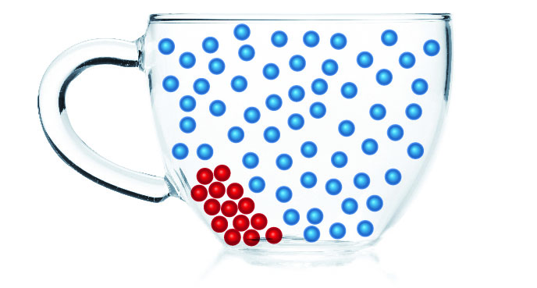→ 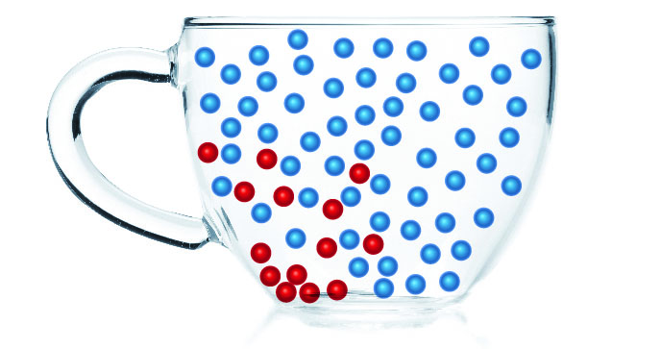→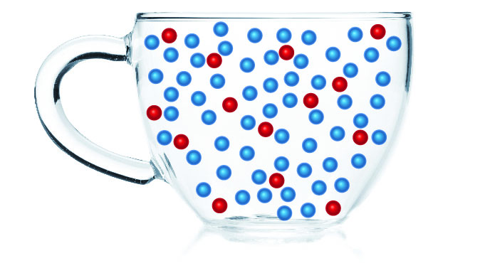

Extend your understanding

6 Explain why 5 g of lead is much smaller than 5 g of aluminium (use the periodic table on page 73 of your student book and elemental atomic mass to explain your answer).

The atomic mass of lead is 207.2, while aluminium is 26.98. This is the mass of each atom. Therefore there are fewer atoms required for lead to weigh 5 g, and more aluminium atoms are required to reach a weight of 5 g.

7 Using the atomic masses you found in question 6, calculate the mass of each of the following aluminium and lead cubes. Using you understanding, explain why 1 cubic centimetre of tungsten weighs 19.25 g, but the same amount of lithium weighs 0.53 g.

Each cube contains 6 ´ 6 atoms = 36 atoms in total.

Lead = 36 ´ 207.2 = 7 459.2 mass

Aluminium = 36 ´ 26.98 = 971.28 mass

Therefore the same size cube has different masses due to the mass of atoms. Tungsten atoms must have a larger mass than lithium atoms for 1 cubic centimetre to be so much heavier.

4.4 The particle model can explain the properties of matter

Student worksheet answers (pages 68–69)

Using the particle model to explain properties of matter

Part 1 – Strength

1 What is tensile strength?

The measure of the flexibility of the links or bonds between particles

2 Would a piece of wire or a rubber band have greater tensile strength? Explain your answer.

The rubber band has a higher tensile strength because it is more flexible and easily stretched

3 What is compressional strength?

The ability of a substance to withstand large forces without being crushed

4 Would a piece of rock candy or a marshmallow have greater compressional strength? Explain your answer.

The marshmallow has a greater compressional strength as you can apply forces without it crushing; applying the same forces to the rock candy will cause it to shatter.

Part 2 – Hardness

5 Explain what a brittle material is.

A very hard substance is brittle if it will shatter easily

6 Would graphite or diamond be the most brittle? Explain your answer.

Graphite is more brittle because, although it is hard, it will shatter when dropped; diamond will not shatter when dropped.

Part 3 – Viscosity

7 Which honey or water would have a greater viscosity? Explain your answer.

The honey will have a greater viscosity than the water because it is harder to pour, is very gooey and is thick

Part 4 – Compressibility

8 Using your knowledge of the particle model of matter, explain why solids or liquids cannot be compressed.

There are no empty spaces between the particles in a solid or liquid, therefore there is no way to reduce the space between particles

9 Using your knowledge of the particle model of matter, explain why it is possible to compress a gas.

Gases have space between their particles, which can be reduced when compacted into a smaller space.

Part 5 – Density

10 Cork is made of wood, but why is it less dense than water? Use the data from Table 4.2 (page 69) of your student book to answer this question.

Cork is made up of wood and air. The density of wood is 0.3 g/cm3 and air is 0.001 g/cm3, compared to water at 1.0 g/cm3. This means that wood already has a lower density and will float on water. Cork has more air within it than wood does, allowing it to float even better.

Extend your understanding

The Greek Sicilian King Hiero (308–215BC) of Syracuse once had a suspicion that his goldsmith was swapping the gold in the crown for a cheaper alloy. By swapping out the gold, the goldsmith would be able to keep the gold and then sell it to make a profit for himself.

Hiero gave Archimedes (a mathematician, physicist, engineer, inventor, and astronomer) the task of proving these charges. Archimedes knew that the King would not approve of him squashing/melting his crown into a cube to measure its volume and compare it with its mass.

11 How did Archimedes overcome the problem of being unable to squash the King’s crown into a cube? What is the name of the method that measures objects in this way? (Hint: refer to the ‘Density Den’ experiment on page 180 of your student book.)

Archimedes placed the crown in water and measured how much the water rose when he did so. In doing this, he was able to determine the amount (volume) that the water raised and use this as the volume of the crown. This has been named the water displacement method as it measured how much water rises when an irregularly shaped object is added to it.

4.5 Increasing kinetic energy in matter causes it to expand

Student worksheet answers (pages 70–71)

Heating particles and expansion

Part 1 – Heating particles

1 Complete the diagram by following these instructions.

a In the circles, draw what particles look like in a liquid state and gaseous state (solid has been provided as an example).

b On the black lines, indicate whether each state change requires an increase or decrease in energy, and an increase or decrease in heat (the first has been completed for you as an example).

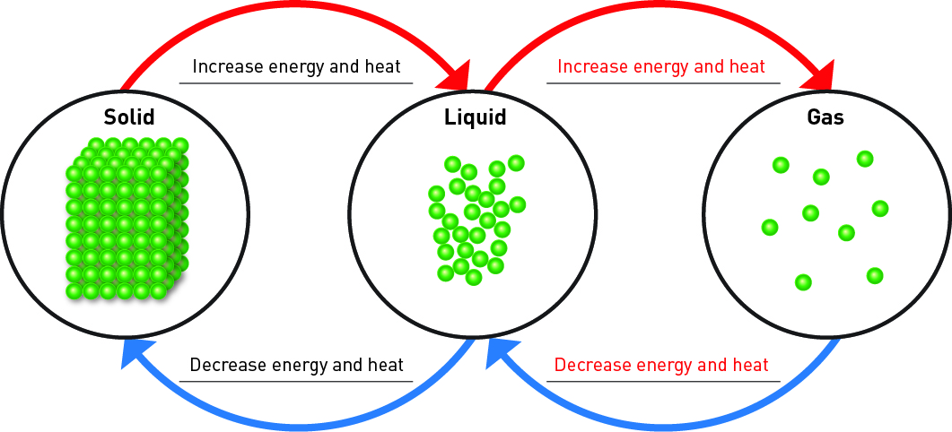

2 What type of energy do the particles that you drew in the above diagram contain?

Kinetic energy

3 When a solid changes to a liquid,

a what happens to the movement of particles?

Particles that are tightly packed spread apart and flow over one another

b why does particle movement change?

As you increase energy, the movement of particles increases

4 When a liquid changes to a gas,

a what happens to the movement of particles?

Particles that are close together but able to move will spread apart and become free-moving

b why does particle movement change?

As you increase energy, the movement of particles increases

Part 2 – Heat causes expansion

5 Train tracks are made of solid metal. Explain why, on hot days, train tracks buckle and trains may not run.

As heat is added to a solid metal, the metal particles will vibrate with more energy and move apart slightly. This causes the metal to expand and buckle.

6 Explain why liquids are used in the internal chamber of a mercury thermometer to measure temperature.

When the thermometer is heated, the liquid mercury in the chamber is heated, giving it more energy. Particles will speed up, take up more space and push the other particles further apart (expand), causing the mercury to rise to a higher temperature measurement.

7 If you cannot open the lid of a jar of spaghetti sauce, running the metallic lid under hot water will make it easier to open. Explain why this is so.

Running the metallic lid under hot water would cause the particles to heat up, gain more energy, move more and expand. When the lid expands it will break the seal of the jar, allowing the jar to be opened more easily.

Extend your understanding

8 Examine the following images.

|  |  |
| --- | --- |
| **A** A metal ball that fits through a hoop | **B** The exact same ball that no longer fits through the exact same hoop |

a Which image demonstrates expansion and which demonstrates contraction?

A = contraction (as it fits through the hoop); B = expansion as it no longer fits through the hoop

b Which image shows equipment that has been heated? How do you know?

B has been heated. We know this because, when heated particles vibrate harder, faster and wider, causing the metal to expand slightly.

c Explain, using your knowledge of expansion and contraction, why the ball can both fit through the hoop and not fit through the hoop.

When in a solid, all particles will vibrate. When they are cool, these vibrations are softer and smaller. When they are hot, the vibrations are harder and wider. This means that when it is cool, the metal ball is contracted and its volume/size is small enough to fit through the hoop. When it is hot, the metal ball has expanded and its volume/size increases to the point where it no longer fits.

4.6 Atoms and elements make up matter

Student worksheet answers (pages 72–73)

Atoms, elements and the periodic table

Part 1 – Atoms and elements

1 What is the word atom or *atomos* used to describe?

Particles that cannot be divided up or broken down any further by chemical means

2 Which is the smallest atom in terms of mass?

Hydrogen

3 How many elements are found naturally on Earth?

90

4 How long does it take an artificial element to break down?

Within a second

5 What properties do artificial elements have?

They are highly radioactive, too large to be stable, and disintegrate almost as soon as they are created

6 What is a monoatomic element?

An element where each particle is made of a single atom

7 Give two examples of a monoatomic element.

Neon, helium

8 What is a diatomic element?

An element where each particle is made of two atoms

9 Give three examples of a diatomic element.

Oxygen, hydrogen, nitrogen

10 The atmosphere is a mixture of many gases. Some of these gases include nitrogen (N2), oxygen (O2) and argon (Ar). Of these three gases, which are monoatomic and which are diatomic?

Nitrogen and oxygen are diatomic; argon is monoatomic

Part 2 – Periodic table

11 What are horizontal rows called?

Periods

12 What are vertical columns called?

Groups

13 Where are metals located?

Left of the zigzag (stairs)

14 Where are non-metals located?

Right of the zigzag (stairs)

15 What are the names of these elements?

Br – bromine; K – potassium; Cl – chlorine; Sn – tin

16 Which element is located in

a period 2, group 1?

Na – sodium

b period 2, group 16?

O – oxygen

17 Which atom has an atomic mass of

a 12.01?

C – carbon

b 40.08?

Ca – calcium

18 Which atom has an atomic number of

a 9?

F – fluorine

b 26?

Fe – iron

Extend your understanding

The periodic table was first developed by the Russian chemist and inventor, Dmitri Ivanovich Mendeleev. In 1869, he arranged chemical elements into the first periodic table, but there was a problem – not all of the chemical elements had been discovered at the time so he left blank spaced where he predicted future elements would belong.

19 Research the following people and briefly state the major discovery they made to the periodic table and the year it occurred in.

a Robert Boyle

1680 – discovered phosphorus

b John Newland

1863 – divided the then discovered 56 elements into 11 groups, based on characteristics

c Marie and Pierre Curie

1886 – started working on the radiation of uranium and thorium, and discovered radium and polonium

d Sir William Ramsay and Lord Rayleigh

1894 – discovered the noble gases (current group 18 elements)

e Glenn Seaborg

1945 – identified the lanthanides and actinides

20 Some of these chemists have been given one of the highest honours for their discoveries. What honour did the Curies, Mendeleev and Seaborg receive?

They had an element in the periodic table named after them

4.7 Atoms bond together to make molecules and

Student worksheet answers (pages 74–75)

Molecules, compounds and mixtures

Part 1 – Molecules

1 What is the difference between a molecular element and a molecular compound?

A molecular element contains two or more atoms of the same element whereas a molecular compound contains two or more atoms of different elements

2 Name and draw two examples of molecular elements below (an example has been provided for you).

Answers may vary.

|  |  |  |
| --- | --- | --- |
| Hydrogen | Oxygen | Nitrogen |

3 Name and draw two examples of molecular compounds below (an example has been provided for you).

Answers may vary.

|  |  |  |
| --- | --- | --- |
| Hydrogen peroxide | Water | Carbon monoxide |

Part 2 – Compounds and mixtures

4 What is a compound?

Two or more atoms of different elements bonded together

5 What is a mixture?

Two or more different compounds that are mixed but not bonded together

6 Name and draw two examples of compounds below (an example has been provided for you).

Answers may vary.

|  |  |  |
| --- | --- | --- |
| Water | Hydrogen peroxide | Carbon monoxide |

7 Draw two examples of mixtures below (an example has been provided for you).

Answers may vary.

|  |  |  |
| --- | --- | --- |
|  |  |  |

8 What is the difference between a molecular compound and a compound?

There is no difference

9 Complete the chart of the different types of substances from your student book, and draw examples of the bottom three substances in the boxes provided.

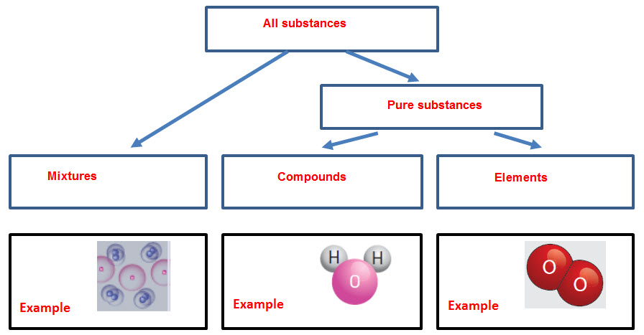Extend your understanding

10 State whether the following diagrams represent an atom of an element, a molecule of an element, a compound or a mixture.

|  |  |  |  |
| --- | --- | --- | --- |
| Molecule of an element | Mixture | Compound | Compound |
| Compound | Mixture | Atom of an element | Molecule of an element |
| Mixture | Compound | Atom of an element | Compound |